Name =Thanjavur Sumanth class=sy6 roll no.=58

Problem

Array addition of two 8 bitt numbers using asm and if greater than 9 using am da spilt

Code

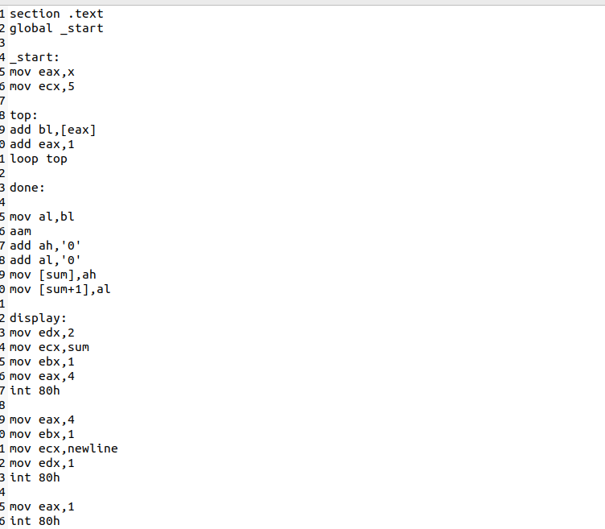

Output

